SPE101 Institutional Economics. Review Questions
1. How would you define an institution? 2
2. Defining what a market is 2
3. What is the relationship between formal and informal institutions? 3
4. The economy is often portrayed as being a system of markets whereas institutionalists argue that the economy is better understood as being system of power. Explain and evaluate the institutionalists conception of economy. 4
5. It is sometimes argued that ‘the market is a good servant, but a bad master’ how do you think an institutionalist would make sense of such an argument? 5
6. Are institutionalists reformers or revolutionaries? capitalists or socialists? 6
7. Institutionalism is often critiqued as ‘description economics’ or being in the business of ‘plausible story telling’. Offer an explanation and evaluation on such critiques. 7
8. So, what does applied theory that is based in an evolutionary approach look like in practice? 8
9. Economists are sometimes accused of suffering from ‘institutional blindness’ Can you explain what this is and identify an instance where you believe it has occurred? 8
10. Explain the significance of habits within institutionalist thought 10
11. Explain the concept of circular and cumulative causation (CCC) and give an example of CCC process identified in the reading by George Argyrous 10
12. What did you think was the most surprising or interesting aspect of the reading ‘Institutional Studies of Economic Development’ by Hugh Stretton? 11
13. Why do institutionalists argue that we can’t totally prevent our values and purposes influencing our social and economic analysis? If they are right, how then should we go about our work? 12
14. Why do institutionalists argue ‘particular models for particular purposes, yes. But one model for all purposes, no.’ 12
15. Do you have any examples of analysis of circular and cumulative causation (CCC) can be applied to real world problems? 12
16. What are the principal weaknesses of institutionalism? 13
17. Further Reading (probably for after semester) 13

How would you define an institution?
An institutional economist would define an institution as a formal or informal rule and then analyse an economic and social systems via analysis the working and evolution of that system’s formal and informal rules.
- Formal institutions (rules) are present in the legal system, constitutions, and codified (written down) policies within organisations. For example, property rights, legal contracts, national constitutions, formal company policies.
- Informal institutions (rules) include such things as matters of etiquette, norms, traditions, and customs. For example, one would form a queue if a group of customers in a shop all want to be served at once.

At the level of the firm/organisation we can also speak of ‘routines’ which are institutions that are not society-wide but are firm/organisation specific. Some institutionalists argue that a firm’s routines largely define its essence and largely dictate its chance of success (or lack thereof) and that firms often face challenges in changing their routines.
An institutionalist would argue that it is the quality, coherence, and nature of institutions of an economy, society or organisation that determines how well it runs, what it produces, how it is produced and whose interests are best served. Given all this, institutions obviously matter a great deal. Indeed, there is no way of even interacting with other people without the presence of institutions.
The way of thinking just described is different to mainstream (neoclassical) economics where the primary approach is to analyse market exchanges between buyers and sellers as win-win situation that is a ‘solved political problem’. Institutionalists tend to argue that the mainstream approach is too limited and essentially facile.

Defining what a market is
A market occurs where people exchange things with one another. In other words, it’s a place where buyers and sellers of goods and services come together. It might be a local swap market where people barter with one another, exchanging apples for oranges. More often, sellers will exchange some good or service for monetary payment rather than bartering. A market can be based in a geographical area such as fruit market (picture left below) or it can be online market such as ebay.
 | 
People also speak of markets for particular goods and services. For example, the ‘coffee market’ refers to all the actors those that are producing/selling and buying coffee across an economy. Note that in such instances there is no particular geographical place or specific website, instead the activity is diffused across the economy. So, the word market can be used in somewhat different ways, but mercifully it is usually obvious as whether people are talking about a geographical location, an online location or the society-wide exchange of a particular good or service.

What is the relationship between formal and informal institutions?
Informal institutions are often necessary to underpin and support formal institutions as otherwise the formal institution may be widely flouted. Consider for example, that currently in Australia there are very significant sales of illegal tobacco. This flouting of a formal institution generates serious problems for law enforcement and for society in general. Part of the problem is that many smokers currently feel it is consistent with their own norms of behaviour and other informal institutions within the community of smokers. Informal institutions whilst not usually being lacked by legal penalties are usually taken very seriously because being sanctioned, excluded and penalised for breaking an informal institution can be painful/costly.
  Fig 3. Social exclusion as a type of punishment | Institutions generally depend on and/or influence, one another. Indeed, informal institutions can sometimes develop into formal institutions. Changes to formal institutions can also influence informal institutions. For example, increased legal penalties (i.e., formal institutions) around drink alcohol and driving in Australia. contributed to changing informal institutions around drink driving and
significantly raised the likelihood of some type of social sanction such as criticism, shunning or social exclusion of those that are known to drink-drive. In general, analysis that does not acknowledge formal and informal institutions, and their co-dependence, might be misleading. The set reading by Stretton illustrates this.
Sometimes the creation of formal institutions is the result of the breakdown of informal institutions due to economic, social or technological change. For example, in 2024 Australian governments brought in a formal rule (i.e. a formal institution) to ban people performing the Nazi Salute. It had been previously unnecessary because few is anyone would do something so offensive, and so stupid. Note also that informal institutions often can arise to cope with the breakdown of formal institutions. For example, see here for some interesting stories about some communities who create informal institutions when hit by natural disasters and where state institutions are support are temporarily absent.
It is relevant at this point to quote the Roman historian Tacitus (born 56 AD) who said ‘the more corrupt a state the more numerous its laws’ (i.e., the more numerous its institutions). Tacitus could mean that if the state is itself corrupt, it will seek to advance its nasty agenda by establishing more controlling formal institutions (e.g., creating institutions that limit freedom of expression or movement). This is something to watch out for, even amongst government’s that claim to be for ‘free markets’ or ‘small government.’ As always, one needs to look at what governments actually do rather than just what they say. Measures that supposedly reduce the scope of the state in society and economy will often in practice simply reconstitute its role, perhaps increasing it scope and size in overall terms.

The economy is often portrayed as being a system of markets whereas institutionalists argue that the economy is better understood as being system of power. Explain and evaluate the institutionalists conception of economy.
Many economists are trained to look at the economy and see only markets, perhaps complemented by a few government ‘interventions’ to correct for ‘market failures’. By contrast, for institutionalists, the economic system (and the social system it necessarily must sit inside of) is primarily composed of institutions (rules) of which markets are but one. Rules, by their very nature, reflect and channel power. If the economy is a system or rules, how could it be anything other than a system of power?
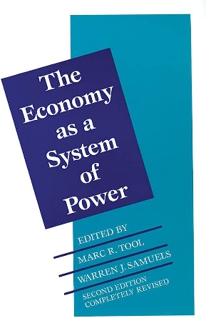
Institutionalists reject the economy as being ‘a system of markets’ because they view the market as being an institution that always needs to be nested inside other institutions. For example, without some basic institutions such as property rights (which need to be supported by the state and legal system) markets will simply not work at all. Furthermore, without a diverse range of other institutions, markets are unlikely to work well, or at least not to serve the social benefit well.
Institutionalists are always interested in the precise institutional context that any market activity is situated within. What are the rules of the game for this particular market they will ask? They reject the idea of a ‘market economy’ and in particular, a ‘free market economy’ as a misleading fiction that directs our attention away from the pervasive role that other institutions besides the market play in shaping economic outcomes. For institutionalists, governments do not just occasionally ‘intervene’ to support occasional ‘market failures.’ Instead, government is usually seen as essential to support the very existence, or at least smooth functioning of markets. So, rather than ye olde market versus state dualism, they assert the necessary co-dependence of market and state. Also, they also stress the importance of informal institutions in the wider society as fundamental elements of any economy.
Given the panopoly of other institutions the institution of the market is dependent on, an institutionalist tends to ask ‘what sort of market exchange are we talking about it here? And also ‘Tell me please about the institutional details that govern the exchange process in this particular specific instance?’ All of this is different to the more common practice of speaking of a generic and amorphous ‘market’ as occurs in a news bulletin or a newspaper article, or of markets that float in the very abstract terrain in a standard economics textbook.
It may be useful at this point to look at this two and half minute video which is how orthodox economists see markets. Notice how it is a general theory of markets (they choose bananas as their example, but it could be any product). The price in the market is set purely by the number of bananas on offer and the amount of people both willing and able to purchase the bananas. Notice that it is such a simple story, one that does not acknowledge all the formal and informal institutions that have allowed the market exchange to occur, and which also greatly condition the way that market exchange plays out. This does not necessarily mean it is all wrong - supply and demand are nearly always relevant variables to consider. However, institutionalists look at the role of supply and demand in a far more contextual and contingent way than most economists are trained to do. This, it can be argued, makes for better, safer and more useful economic analysis.

It is sometimes argued that ‘the market is a good servant, but a bad master’ how do you think an institutionalist would make sense of such an argument?
Institutionalists would probably reconstitute this statement somewhat by arguing that a market’s ability to function for social good, or ill, is dependent on the effectiveness of the institutional structure that the market sits inside. For institutionalists, the question is not usually about whether the good society should seek to either eliminate or increase the use of markets. Instead, they are more nuanced and qualified: rather than market - ‘yes or no’ they would instead ask market - ‘when? where? And in particular, how?’ A focus on the ‘how’ of markets then naturally leads to consideration of the other institutions that the institution of the market will necessarily be nested inside of, and which will vitally affect a market’s ability to function well, or to function at all.

Institutionalists do not usually exhibit agoraphobia – a fear or inherent hostility to markets exhibited by some (but by no means, all) socialists. Instead, institutionalist have a stance of provisional or cautious openness. Before reaching a verdict on whether there is a role for a market in a particular time and place, they will tend to ask searching questions like:
(1) does the creation (or maintenance) of a particular market suit the particular purpose and context at hand or would other institutional arrangements work better?
(2) are the necessary institutions that are required to support and direct markets able to be put in place? Note that the capacities and integrity of government and civil society are critical to quality of institutional design around markets.
(3) can the necessary supporting institutions be maintained over time in a way that will promote the social good? The capacities and integrity of government and civil society are again critical to this question. A follow-on question to this is whether an increase in the role of markets is likely to promote or erode such capacities and integrities?
Some radical political economists see the institution of the market, particularly when combined with private property, to be irredeemably problematic and counterproductive to modern societies. By contrast, institutionalists are usually more agnostic in terms of any having general stance towards markets.
A good illustration of a more reformist/institutionalist approach to markets is the report Shaping Inclusive Markets which is not about promoting or eliminating markets per se, but instead the central drama is the struggle to create the appropriate supporting institutions around particular markets.

Are institutionalists reformers or revolutionaries? capitalists or socialists?
Institutionalism is flexible enough in its ideological foundations to house most ideological positions and advocates of particular types of economic system. Consider for example the Nobel Prize Winner Elinor Ostrom who explicitly defined herself as ‘institutional political economist’. Elinor’s very institutionalist concepts of social governance and polycentric governance are not tied to any particular program. This can be illustrated by the fact that her work is of ongoing interest to conservatives , left-wing radicals and also those in the political centre who seek to promote the efficacy of any group whose members need to work together to achieve a set of common goals.
Some institutionalists have been pragmatic reformers of capitalism who have deeply involved in politics (e.g., J K Galbraith and Gunnar Myrdal). By contrast, some institutionalists on the left such as Phil O’Hara and William Dugger are radical institutionalists who have sought to be build bridges between institutionalism and Marxism. The prominent institutionalist theorist Geoff Hodgson, who actually started his career as a Marxist, pivoted through institutionalism to become a liberal democrat and who now (warrantably or not) worries about the return of statist conceptions of socialism that are reminiscent of the former USSR.
The sociologist Erik Olin-Wright, whose work I would personally classify as a radical institutionalist, argues against the traditional tight dichotomy between capitalism and socialism. For Olin-Wright, any progressive reform of capitalism is making it more socialist and so our focus should be on promoting socialism within capitalism, rather than just a socialism that is beyond capitalism. Furthermore, for Olin-wright socialism is about promoting social power over both market power and state power, as opposed to other conceptions of socialism with often looks a large extension of state power. He would regard such variations of socialism, as really being statism rather than socialism.
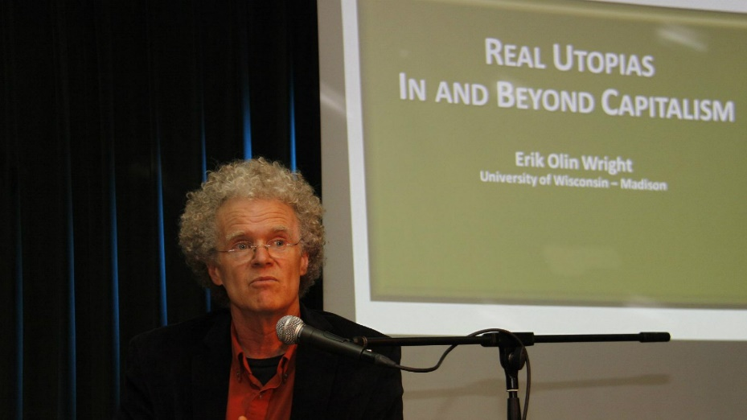

Institutionalism is often critiqued as ‘description economics’ or being in the business of ‘plausible story telling’. Offer an explanation and evaluation on such critiques.
There is a basic requirement in intellectual analysis to ‘show your working’ as mathematician would say. One cannot simply ‘do analysis.’ There is no ‘fact’ without a theory or some prior mental framework that proceeds it. Just as the mathematician must ‘show their working’ behind a particular conclusion, so does the economist and any other social scientist. Within academic discourse, an inability or unwillingness to show the exactly how you reached your conclusion is usually rightly seen as being very suspect and indeed, non-intellectual. ‘Seeing is believing’ might seem like the beginning and end of doing good analysis. However, we see with our minds as much as our eyes. For example, look at the diagram below. What animal is it an image of? A duck? A rabbit? Are you sure? Look again, can you see another animal? Clearly, the brain needs impose meaning on the sense data that his hitting the back of your retina. It can only do so be recourse to prior mental frameworks of some sort. It is for this reason that some argue that ‘theory precedes observation’.

What exactly are your eyes telling you here? Is it really your eyes that are even deciding?
Against this backdrop of always having to ‘explain your working,’ institutionalists have often been accused of not having a sufficiently developed theoretical core. For example, Ronald Coase went so far as to argue the original institutionalists such as Veblen were anti-theoretical (Coase, 1984). The response to this critique is to argue that institutionalists were instead drawing upon on a different type of theory, one that was less universalistic, more evolutionary, and far less mechanistic and mathematical. It can be argued that these characteristics are usually theoretical virtues rather than vices. However, nearly all mainstream economists, including Ronald Coase obviously disagree with such a position.
So, institutionalists are of the view that they do have a theoretical framework to guide their analysis and support their conclusions. But what is it exactly? They draw on the framework of Darwinian evolution (i.e., the process of variety, retention, and selection). Digging into this properly is beyond the scope of what we can do in SPE101 but for more on the role of evolutionary thinking in political economy and economics see (Beinhocker, 2006; Hodgson & Knudsen, 2010; Vromen, 2004). A particularly accessible (and I suspect, important) example of evolutionary thinking has been undertaken by David Sloan Wilson who has generalised Nobel Prize winning institutional political economist Elinor Ostrom’s work on polycentric governance and managing common resources into an evolutionary framework that also incorporates psychological theories that are also somewhat evolutionary in their nature. The chapters on evolution of Eric Beihocker’s The Origin of Wealth would also be an excellent place to start if you want to know more about evolutionary theorising in economics. Not also that many institutional economists actually call themselves evolutionary economists and the two terms are usually seen as being one and the same thing. See for example this text:
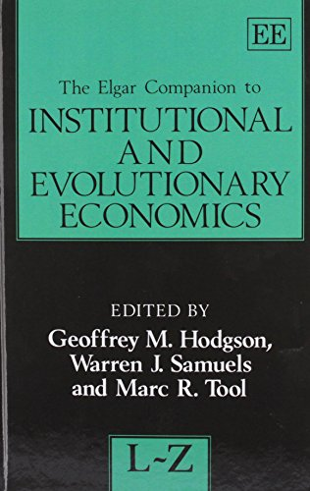
For online resources on evolutionary theorising in economics and the social science in economics see hCuring Economics’ Addiction to Unreal Theories, The Woman Who Save Economics from Disaster and pages 12 to 14 of the extra reading for this week written by yours truly. Evolutionary theorising in the social sciences has a dark history of promoting racist and inegalitarian ends, but a strong argument can be made that his is due to a deeply flawed understanding of what Darwin evolution actually is.

So, what does applied theory that is based in an evolutionary approach look like in practice?
Institutionalists such Geoff Hodgson argued that argue the economic and social world is evolutionary in its general nature and a three-step Darwinian process of variety, retention and selection can capture the evolution of biological selves but also habits and institutions. However, they also argue that evolution is the general theory we often need context-specific theory (that is informed by evolutionary principles) to make sense of specific phenomena. This type of mid-range (or applied) theory is currently not that developed in institutionalism. The best example Nelson and Winter’s evolutionary theory of the firm and Freeman and Hannan’s organisational ecology. You can get an introduction to both theories here.

Economists are sometimes accused of suffering from ‘institutional blindness’ Can you explain what this is and identify an instance where you believe it has occurred?
Institutional blindness occurs when people, including economists, fail to grasp the need to focus on developing and maintaining institutions beyond just the market and/or they simply assume the necessary support institutions are present or will emerge quickly and naturally. Such an orientation to analysis usually spells trouble. As was argued in the lecture, ‘studying markets without reference to institutions is like studying the movement of blood without reference to the body’ (Coase, 1984).
It must be conceded that most economists recognise the existence of at least some institutions (money, private property right and a formal legal system). However, they usually only really acknowledge a limited number of institutions and few of those really enter into the analysis, particularly if those institutions cannot be reduced to variables that can modelled mathematically. In other words, mainstream economists often adopt a ‘not but ignore’ approach to the study of nearly all other institutions beyond the institution of the market itself.
It should also be noted that there is much disagreement about which institutions (both formal and informal) are central and which are peripheral in accounting for economic success and failure. There are also debates about the importance of institutions relative to other determinants such geography, climate, soils, natural resources etc. This week’s extra reading by Samuel Bowles makes an argument for the centrality of institutions in explaining differences in rates of economic development between countries.
Context Matters

When it comes to policy advice, institutionalists usually advocate that one always needs to consider the social and technological facts on the ground in deciding what institutional changes need to be mode. Consider an example drawn from a textbook I co-wrote, whereby we recount the (true) story of economics graduate whose first job was to advise the government of a rice-growing country where it should put its research efforts. They had been told that two modern techniques for rice milling had been developed elsewhere, and they were asked to determine which of these two technologies should be selected. The young economist analysed the requirements for producing a ton of rice under each of the two competing technologies, including labour, machinery, fuel, and raw materials. They calculated the monetary costs for these inputs, and, finding that Technology A could produce a ton of rice at slightly less cost than Technology B, recommended that the government invest in the more “efficient” technology.
Returning a few years later, the economist was horrified to discover what had happened when the country implemented his suggestion. It turned out that the traditions of that country included strict norms (informal institutions) in relation to the division of labour: specifically, what work women were allowed to do and what was defined as men’s work. Technology B would have been neutral in this regard, maintaining the same ratio of “male jobs” to “female jobs” as had existed before. Technology A, however, eliminated most of the women’s work opportunities. In a society where women’s earnings were a major contributor to food and education for children, the result was a perceptible decline in children’s nutrition levels and school attendance. Charged with determining which technology was best, the young economist had not considered the institutional context. In his race to determine what was the most efficient technology had not really even asked as ‘efficient at doing what exactly?’

Explain the significance of habits within institutionalist thought
Institutionalists are somewhat unique in the emphasis they place on habits. From an institutionalist perspective, habits are understood to mediate the relationship between the individual and society, or more abstractly and generally, between individual agency and social structure. Habits can amplify or attenuate our instinctual propensities (both when those propensities are pro-social and anti-social). Habits can give rise to social institutions, but they are also the form in which many institutions are internalized and operationalised within an individual’s mind and behaviour. Note also that any such shaping of habits will then have a knock-on effect over shaping what instinctual propensities are amplified or attenuated. Habits are, analytically speaking very important to institutionalists because they are the go-between or pivot that allows institutionalists to explain how we can both shape the world but to also be shaped by the world (Hodgson, 1998).
An institutionalist view of the relationship between instincts, habits, and institutions
Instincts
↓↑
Habits
↓↑
Institutions
For more on habits and instincts in institutional though see (Hodgson, 1999, 2003; Jennings, 1999). There is also some literature in psychology that seems relevant (Graybiel, 2008; Lally, 2009) though this all rather advanced and should probably wait till after semester unless you have a lot of time available at the moment.

Explain the concept of circular and cumulative causation (CCC) and give an example of CCC process identified in the reading by George Argyrous
CCC in its most basic form is about increasing returns. Event A causing Event B which then causes an even greater instance of Event A, which then causes a greater instance of B (and so and so on with both the A and B continuing to accumulate in size). Of course, CCC can involve more than two variables, perhaps progressively sucking them into a chain of causation rather like a vortex. The reading by Argyrous, provides copious examples of CCC in practice and is well worth a read if you have the time, but here is example of circular and cumulative process which I have adapted just slightly from pages 56-7 of Marc Cohn’s Reintroducing Macroeconomics

Circular and Cumulative Causation: The Movie
The movie opens with Harrison Ford (CEO of General Motors) sitting at a large desk poring over sheets of paper and looking frantic (in the way the only Harrison Ford can). There are two other people in the room. A stylishly dressed woman indicates that she thinks the economy is healthy and the General Motors should continue production at current levels to maintain market share. A man interrupts. He urges modest production cutbacks to prevent General Motors from building up a backlog of unsold cars.
Ford grimaces and indicates he is going to shut down 15 plants and lay off 200,000 workers. He thinks things are far worse than either of them imagines. Everybody looks worried.
The camera fades: a newspaper headline spins into view, “General Motors Cuts Back 200,000 jobs, Goodyear Tyre and US Steel Follow Suit.” The screen fades out. Next month’s newspaper spins into view. The lead article begins, “Sears, Wal-Mart, and K-Mart, fearing falling worker incomes, have cut back on consumer durable orders. Whirlpool and GE have announced factory closings.” The screen fades. We are back at the General Motors boardroom. Ford is still Frantic. General Motors’ initial announcement has spurred larger production cutbacks across the economy than anticipated. Even after cutting 200,000 jobs, Ford fear that General Motors is producing more cars than it can sell. He decides to make yet further cutbacks.
The scene shifts to the floor of the New York Stock Exchange. There is pandemonium. General Motors stock plummets by 20 percent, then rises 20 percent and then falls again.
The key thing to understand here is the emphasis on how instability causes further instability rather than gravitating back to balance or equilibrium.

What did you think was the most surprising or interesting aspect of the reading ‘Institutional Studies of Economic Development’ by Hugh Stretton?
Obviously, this is for you to answer. I appreciated that Stretton emphasised how pragmatic institutionalists can be, how they can countenance second-best rather than optimum outcomes, realizing that issues such as path-dependence and the existing distribution of power, sometimes make an optimal outcome impossible in the here and now.
There is one aspect of the Stretton reading that is a little dated in that microcredit has sometimes (though not always) fallen short of its early promise. This does not necessarily mean microcredit is inherently flawed or should not be used. What is does suggest is that the institutions around it are obviously critical and need to be matched to the social and technological facts on the ground in each instance. For example, what are the precise terms of the loan? The particular rate of interest charged? What happens in the case of default? What should loans be given? The devil is, as usual, very much in the institutional details. Any tool badly used and implemented is likely to produce bad results and microcredit is no exception. For those of you interested in such issues, you might like to look at savings groups and direct provision of cash as alternatives to microcredit.

Why do institutionalists argue that we can’t totally prevent our values and purposes influencing our social and economic analysis? If they are right, how then should we go about our work?
The social and economic world is often complex and so our analysis of it is necessarily selective and we need to undertake various simplifications and abstractions, or analysis simply becomes too open-ended and unwieldy. The thing to note is that analyst’s values or purposes always exert at least some influence over which particular selections, simplifications and abstractions are to be made. Furthermore, values and purposes influence what questions do (and don’t) get asked, further debunking the idea of value free social science.
In contrast to what has just been argued, some mainstream economics and Austrian economists argue their analysis is objective and value free. Institutionalists reject the idea of value free economic and social analysis and instead recommend that we should be constantly aware of our how our own values and purposes are unavoidably permeating through our analysis. We should be open to both ourselves and others about what our values and purposes are. We should also avoid obvious bias and other markers or poor and deceptive scholarship (for more on the role of values in economic and social analysis seeBoumans, Davis, Blaug, Maas, & Svorencik, 2010; Pheby, 1987; Stretton, 1969).

Why do institutionalists argue ‘particular models for particular purposes, yes. But one model for all purposes, no.’
Because institutionalists place great importance on context, universal models and theories are viewed with considerable scepticism. Culture, history, politics, norms all matter and can be quite different from location to location. Even the same places change over time and may even change in response to your studying it. Institutionalists tend towards the idiographic (thus emphasising the centrality of the particular, the contextual and the contingent) whereas the economic mainstream is strikingly nomothetic (i.e. assuming that they are some universal laws that are always at work with everything else being statistical surface noise). As the very prominent mainstream economist Larry Summers once said, ‘spread the truth, the laws of economics are like the laws of engineering: one set of laws works everywhere.’ Institutional economists strongly disagree with this nomothetic view of things. Duncan Green at Oxfam notes that in practice this divide often translates as follows: On one side are the ‘best fit’ institutionalists and complexity people, with their focus on path dependence, evolution and trial and error. On the other are the ‘universal law’ experimentalists, offering the illusory certainty of numbers, and (crucially) comfort to the political paymasters…”

Do you have any examples of analysis of circular and cumulative causation (CCC) can be applied to real world problems?
Go straight to 219-221 of this chapter for more applications of circular and cumulative causation. Looking at examples makes it much easier to grasp. This chapter section on CCC is only three pages long, but it does a better job of answering you question than I can do here in just a paragraph or two. Do let me know if anything is unclear.

What are the principal weaknesses of institutionalism?
The first thing to said in response to this question is that what can be regarded as a weakness versus a strength in a school of thought is in the eye of the beholder to some extent because it depends a lot of the criteria and what you think constitutes good economic and social analysis. It is probably the sort of question we should come back to at the end of semester when we have surveyed the other schools (and their underlying view). However, let me at least make some basic points. Namely that institutionalists are often criticised by neoclassical orthodox economists for lacking a fully developed theoretical foundation. However, it could be countered they simply have a different theoretical foundation to neoclassical economists (i.e. institutionalist adopt a Darwinian evolutionary framework) and that neoclassical economists simply cannot understand and/or accept (perhaps because it is too threatening to their own cherished foundational beliefs). In particular, they feel a satisfactory approach to economics is necessarily heavily mathematical and quantitative whereas the institutionalists are more orientated to the qualitative.

Further Reading (probably for after semester)
Here is an additional reading on institutionalism written by Frank Stilwell, from his excellent textbook Political Economy: The Contest of Economic Ideas. If you have the time and inclination to read more on institutionalism, here is a great place to start.
Phil O’Hara’s (2022) Principles of Institutional and Evolutionary Political Economy Applied to Current World Problems is an excellent resource for those wanting to know more about what institutional economics looks like in application. You should be able to find this in a university library and the paperback and e-book price is not too bad (for an academic text)
Hugh Stretton’s Economics: A New Introduction is written by from a more or less institutionalist perspective. The first section of the book (pages 2 to 55) gives a wonderful account of institutionalist methodology. In other words, how institutionalists set the boundaries of analysis, how they understand the role of values, the nature of causation, the appropriate role for mathematics and much else.
This is a deep dive into evolutionary thinking, whilst focused on the Austrian and neoliberal economist Frederich Hayek, it does a good job of explaining why evolutionary thinking is not necessarily tied (at all) to a libertarian or right-wing ideology.
For those with an eye on policy applications, read pages 483 to 501 of this reading which is from Sam Bowles’ Book: Microeconomics: Behavior, Institutions and Evolution. This section of the chapter provides an excellent analysis of the strengths and weaknesses of different forms of governance (states, market and communities). The reading is from SPE104 microeconomics and its needs its own explanatory lecture, but you should be able to get a fair bit out of it now. Let me know if there are particular terms or concepts that you need help clarifying. The terms are often less complicated than they sound. For example, ‘residual claimancy’ simply means who gets remaining sum of money (or more generally, benefits) after all the costs have been accounted. For example, who would get a firm’s profits? The owners? The managers? Or the workers? As is usually the case, daunting sounding terms and ideas, are eminently understandable if somebody can explain them to you in a clear and careful way.
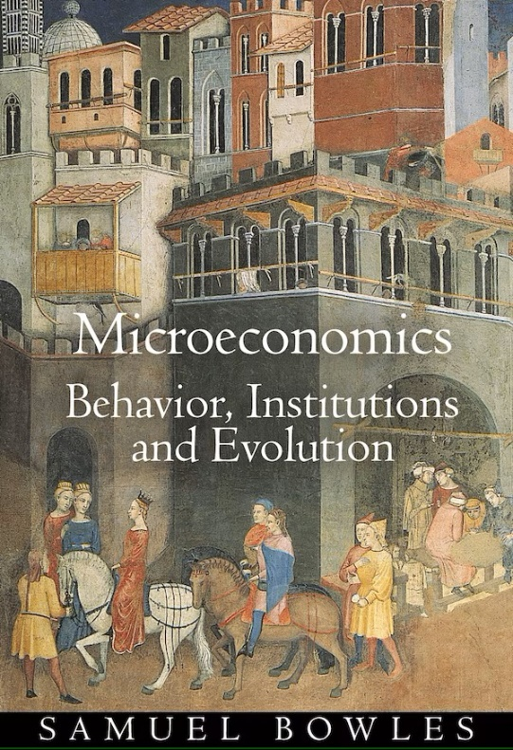
References
Beinhocker, E. D. (2006). The origin of wealth: evolution, complexity, and the radical remaking of economics. Boston: Harvard Business School Press.
Boumans, M., Davis, J. B., Blaug, M., Maas, H., & Svorencik, A. (2010). Economic methodology: understanding economics as a science. Basingstoke: Palgrave Macmillan.
Coase, R. H. (1984). The New Institutional Economics. Journal of Institutional and Theoretical Economics, 140(1), 229-231. Retrieved from http://www.jstor.org/stable/40750690
Graybiel, A. M. (2008). Habits, rituals, and the evaluative brain. Annual Review of Neuroscience, 31, 359-387.
Hodgson, G. M. (1998). The approach of institutional economics. Journal of Economic Literature, 36(1), 166-193.
Hodgson, G. M. (1999). Institutions and Habits. In P. A. O'Hara (Ed.), Encyclopedia of political economy (pp. 535-538). New York: Routledge.
Hodgson, G. M. (2003). The hidden persuaders: Institutions and individuals in economic theory. Cambridge Journal of Economics, 27, 159-175. doi:10.1093/cje/27.2.159
Hodgson, G. M., & Knudsen, T. (2010). Darwin's Conjecture The Search for General Principles of Social and Economic Evolution. Chicago: The University of Chicago Press.
Jennings, A. (1999). Instincts. In P. A. O'Hara (Ed.), Encyclopedia of political economy (pp. 518-520). New York: Routledge.
Lally, P., van Jaarsveld, C.H.M., Potts, H.W.W. & Wardle, J. . (2009). How are habits formed: Modelling habit formation in the real world. European Journal of Social Psychology, 40(6), 998-1009. Retrieved from http://www3.interscience.wiley.com/journal/122513384/abstract
Pheby, J. (1987). Methodology and economics: a critical introduction. Basingstoke: Macmillan.
Stretton, H. (1969). The political sciences: general principles of selection in social science and history. New York: Basic Books.
Vromen, J. J. (2004). Taking evolution seriously: what difference does it make for economics? In J. B. Davis & A. Marciano (Eds.), The Elgar Companion to Economics and Philosophy (pp. 102-131). Northhampton: Edward Elgar.

Note the goods are tangible objects (i.e. things you can drop on your toe such as a brick!) and services are intangible things that you can’t drop on your toe (for example, a haircut or taxation advice).

